Document Manager

Overview : Document Manager as the name suggests is a service which will allow creating , editing and viewing documents online. It should support 2 most popular type of documents Word and PDF. The document management service should be a multitenant service. Each tenant should be able to register with the document service. The storage (known supported storage types only) of the documents should be configurable per tenant. If the location is not set then the document management service should use the default storage ( FTP server or GitHub) configured for the service.

Flow diagram for managing documents via document Manager

The components in Orange are part of the Document Manager.

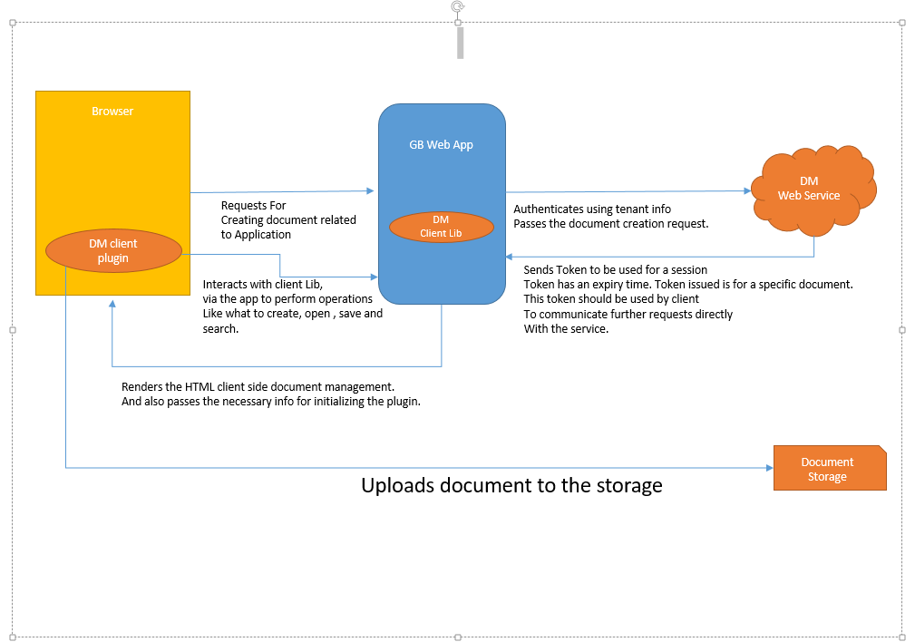

DM

Web Service

Document Storage

GB Web App

Browser

Requests For

Creating document related to Application

Authenticates using tenant info

Passes the document creation request.

Sends Token to be used for a session

Token has an expiry time. Token issued is for a specific document.

This token should be used by client

To communicate further requests directly

With the service.

Renders the HTML client side document management.

And also passes the necessary info for initializing the plugin.

Uploads document to the storage

Interacts with client Lib,

via the app to perform operations

Like what to create, open , save and search.

Document Manager will compose of 3 distinct components

1. Document Management and Storage Web API.

This API should be a web service that would expose the necessary API’s to store and retrieve documents related to a tenant.

1. Document Management Client Lib

This could be server side library which is used to interact with the Document Service and is also responsible for rendering the HTML for the browser.

1. Document Management Client Plugin

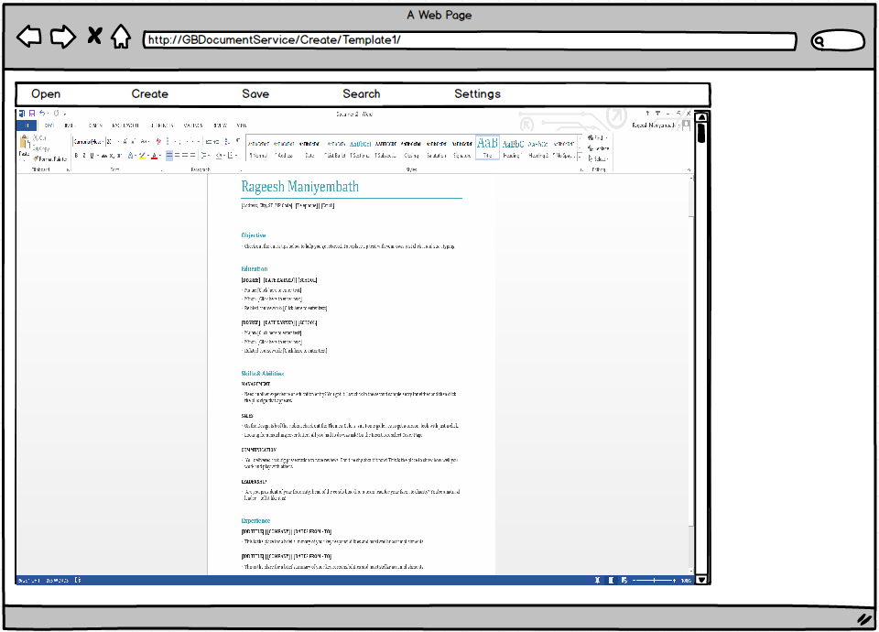

The client should be a browser plugin and also an add-in. The server side info should be configurable for the client side plugin. The client plugin should be initialized with the info it needs to interact with the server side service. The browser plugin should have 2 frames

1. Menu Frame

The Menu frame should have the following options

* Create : Option to create new documents from existing document on the client box or a new document from an existing Template.
* Open : Load an existing document on the server , this document can be edited on the client side and the changes uploaded to Server when the document is Saved.
* Save : Option to Save document in the Document editor Frame. The saved document is saved remotely.
* Search : Option to search documents for the specific Tenant.

1. Document editor Frame

This is the frame which will load word or pdf editor , which will allow the user to edit the document. This requires the client to have the required software like MS word or PDF writer required for editing the type of document.

Template Based documents:

Document Manager should allow Tenants to define document templates. A user can define tags (place holders) in the document template. DM should allow to create a new document based on an existing template and the set of values for the tags. The new document should have the tags replaced with the values provided during creation.

Document versioning:

The service should track all the changes done to a document, every save should result into a new version of the document. One should be able to view the previous version of a document. Latest version of the document should be the default document to be used unless a specific version is requested.